PM-15-09
VM-15-10

May 29, 2015

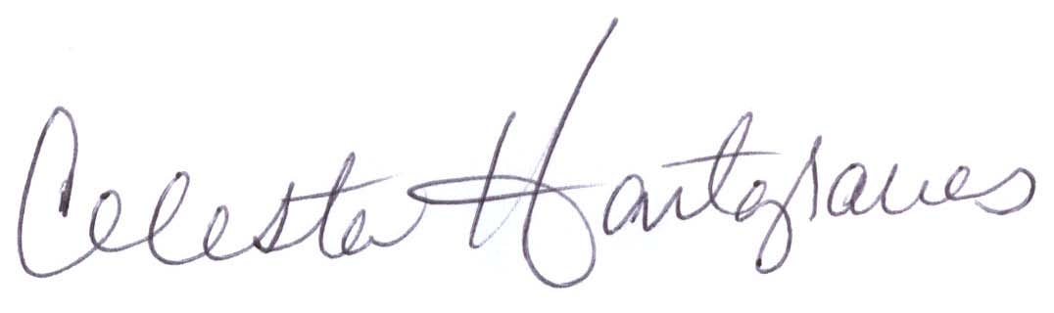
MEMORANDUM FOR ALL HOME AND COMMUNITY BASED CARE PROVIDERS

FROM: Celesta Hartgraves, Director
Division of Senior and Disability Services

SUBJECT: Inappropriate Referrals

This memo is written as a follow up to PM-15-02/VM-15-02 dated November 26, 2014, and is an effort to continue to seek efficiencies in operations. The Division of Senior and Disability Services (DSDS) Call Center continues to receive inappropriate referrals from Home and Community Based Services (HCBS) providers. Current participants of HCBS or participants not active for Medicaid benefits are not appropriate for referral to the Call Center. The DSDS Call Center’s role is to process new referrals for Medicaid funded HCBS. The number for initial referrals is (866)835-3505. Over 14% of the total referrals received via fax in the months of February, March and April 2015 were inappropriate.

The following information is intended to serve as a guide for HCBS provider agency staff responsible for the review and processing of referrals forwarded to the DSDS Call Center. It is the Division’s intent that provider agencies ensure these staff have reviewed this memo including the supporting information, and have received a user id/password for the data systems described to facilitate the referral process.

Prior to contacting the Call Center, provider staff shall review referrals to ensure the referred individual is approved for Medicaid benefits and does not have an existing authorization for HCBS.
- Individuals not receiving Medicaid benefits can be referred to the Family Support Division website (http://dss.mo.gov/mhk/appl.htm) for Medicaid application. Additionally, individuals not eligible for Medicaid may be referred to the Area Agency on Aging (http://health.mo.gov/seniors/pdf/AAARegion.pdf), or the Center for Independent Living (http://mosilc.org) for other resources in the participant’s location.

- Participants with an existing authorization for HCBS shall be referred to the appropriate DSDS Regional Evaluation Team at (http://health.mo.gov/seniors/homecomservices/pdfBHCSEval Team.pdf).

Verify Medicaid eligibility through either the:
- MO HealthNet Division’s Interactive voice response (IVR) system at (573)751-2896. Reference Section 3.3.A in the MO HealthNet Division’s manuals (http://manuals.momed.com/manuals/) or
- Internet at www.emomed.com. Reference Section 3.3.C; or
- The HCBS Web Tool Eligibility Section on the Participant Case Summary.

Medicaid participants in a MO HealthNet managed care program should be referred to the managed care agency the participant is enrolled in for evaluation and authorization of home care services. DSDS cannot authorize HCBS for a participant in a managed care program.

Review the HCBS Web Tool to determine if there is a current authorization for HCBS:
Access the HCBS Web Tool for the potential participant. On the Participant Case Summary screen, scroll to the Eligibility section and review for the message shown below. If the following message is noted, the participant has an existing plan outside of the HCBS Web Tool and shall be referred to the appropriate DSDS Regional Evaluation Team.
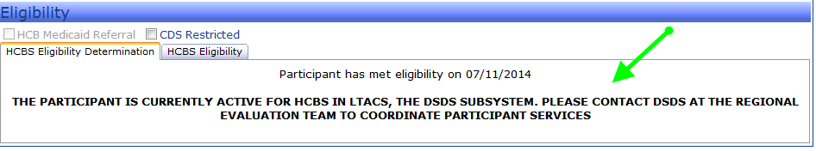

If the above message is not displayed in the Eligibility section, scroll to the bottom of the Participant Case Summary screen and look for an open case in the Case Items Section (indicated by a yellow bar). If there is not an open case line, there is no authorization for HCBS in the Web Tool. If an open case is noted, select the expand button and review the Case Stages to locate a current Prior Authorization-Care Plan Service (PA) if applicable. Not all participants with an open case line will have a prior authorization. Participants with a current PA shall be referred to the appropriate DSDS Regional Evaluation Team.
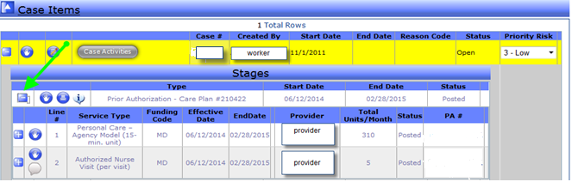

HCBS Web Tool Functionality
The Division has provided information specific to HCBS Web Tool functionality at http://www.health.mo.gov/seniors/hcbs/. Provider agency staff should review the HCBS Web Tool Instruction power point for step by step instructions located at http://www.health.mo.gov/seniors/hcbs/webtoolresources.php.
Submitting Fax Referrals
Providers can also submit referrals via fax. These referrals must be completed using the ‘Home and Community Based Referral’ form (dated 01/15). The completed form should be faxed to (573)526-2915. The referral form is located on the DSDS website at http://www.health.mo.gov/seniors/hcbs/hcbsmanual/doc/8.00appendix3da1referralforhcbs.doc.
Submitted forms should not be “prefilled” as the submitted form should be specific to the needs of the participant requesting the HCBS services.

Provider staff should review the form to ensure accuracy of the information provided prior to faxing. The Division will review all faxes received to check for accuracy and to improve efficiency. Continuous submission of inappropriate referrals may result in the referral being sent back to the referring agency for correction.
Any questions regarding this memorandum should be directed to the Bureau of Program Integrity via e-mail at programintegrity@health.mo.gov or by phone at (573)526-8557.

CH/cj

